ONLINE RETAIL PERFORMANCE DASHBOARD – EXPLORATORY DATA ANALYSIS REPORT
This report presents an exploratory data analysis of an online retail dataset. Analysis was performed to understand sales performance, customer behaviour, and product trends using a Power BI dashboard.
DATA CLEANING PROCESSES; This dataset was cleaned by removing duplicates, handling missing values, and standardizing date and text formats. Numeric values such as quantity and unit price were validated to ensure accuracy before analysis.
KPI SUMMARY: Analysis carried out showed a net revenue of 9.7M after accounting for losses from returns. A total of 4,400 customers generated 25,900 orders within 2010-2011. Products return rate stood at 9.3%, indicating a moderate level of product returns affecting overall sales performance.
VISUALIZATIONS AND INSIGHTS;
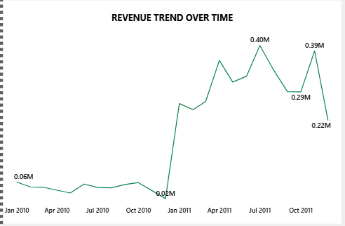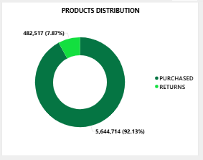
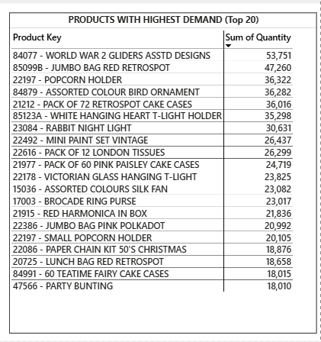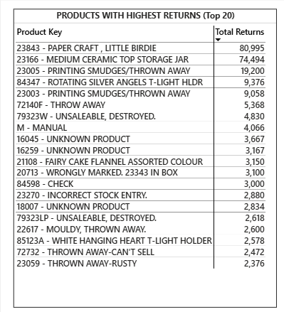
REVENUE TREND OVER TIME; From my analysis, revenue was directly affected by the number of orders. Between the month of November to December of 2010, orders placed greatly reduced to (51), thus that decline. Thereafter there was strong recovery from January of the following year by a total of (822) orders. Peak performance occurred in June with the highest order activity of (1,017) orders.
PRODUCTS DISTRIBUTION; Between 2010 to 2011, total purchases were 5,644,714 with returns of 482,517, showing that small portion of overall transactions were returned.
PRODUCTS WITH HIGHEST DEMAND/ HIGHEST RETURNS; The highest purchased item is “Paper Craft, Little Birdie” but all of the pieces were returned, making it the most returned product too. This is a matter that should be looked into.
The second most purchased product was “World War 2 Gliders ASSTD Designs” with a total of 53,751 purchases.

